**Q.3**

**Form Personalization:**

1. **Making Document Number Field Compulsory**

* Go to Oracle Application and under your user add the responsibility “Receivables Super Vision Corporation Japan” and save it.

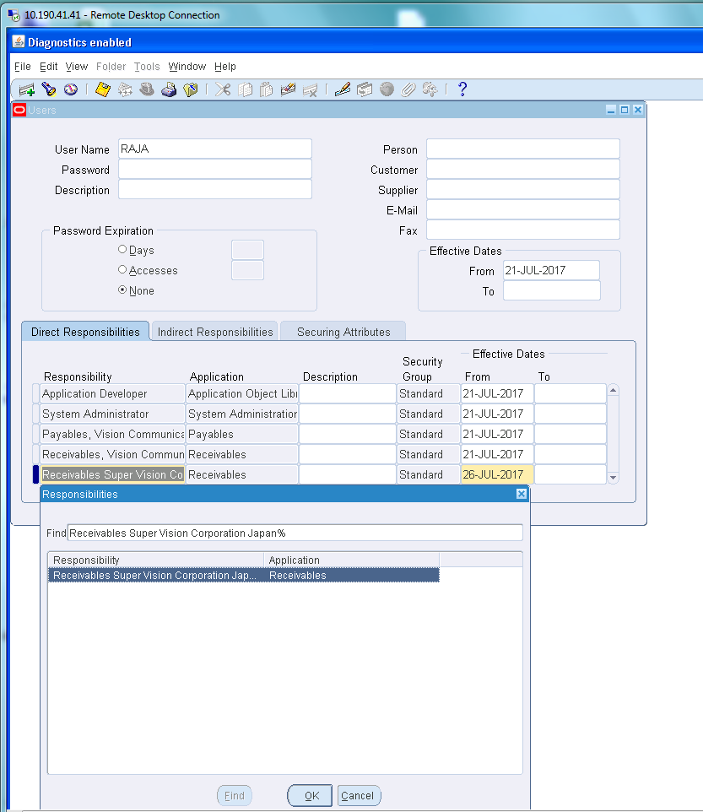

* After creating the responsibility, navigate to “transaction” and go to “transaction” sub navigation and open it.
* Here we notice that “Document Number” is not mandatory and is optional.
* We have to make is mandatory by creating a rule in the “HELP” MENU.
* Go through the Help navigation to personalize the rules.

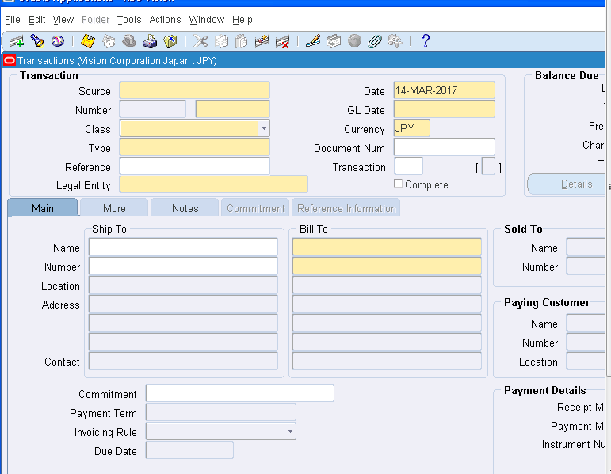

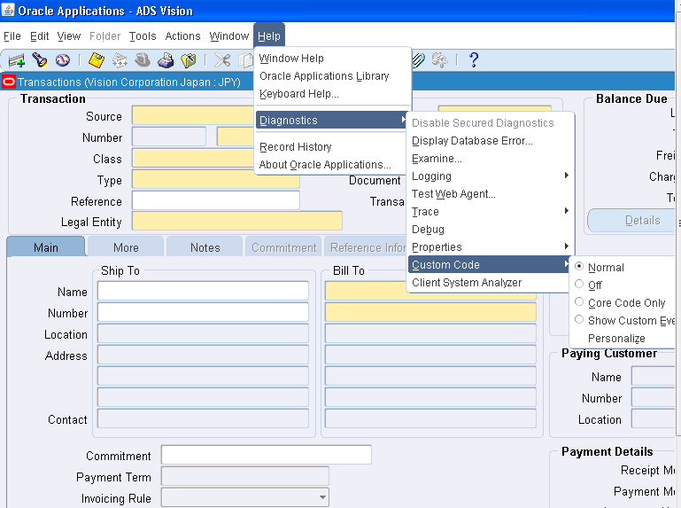

* In the personalization form, create a new rule “Document Number Compulsory “ and assign the user in the Level field in the Condition block.

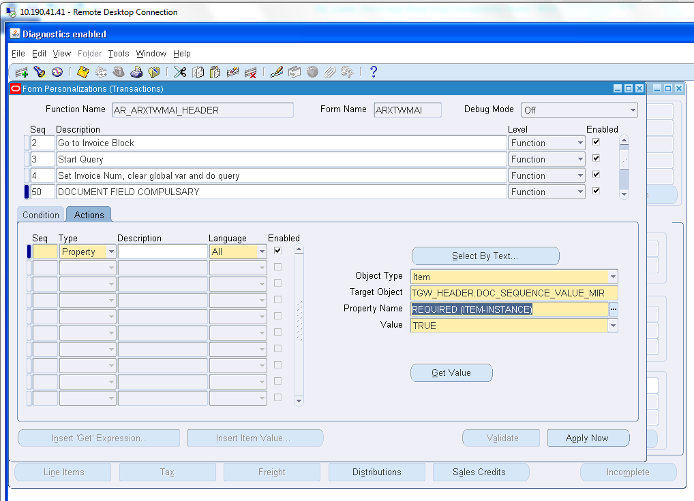

* Go to Actions Block and select the Target object “TGW_HEADER.DOC_SEQUNECE_MIR” which represents the “Document Number”field.
* Select the property name as “Required (Item Instance)” and make it “TRUE”.



* AFTER MAKING IT TRUE,VALIDATE AND APPLY IT.
* GO TO CONDITIONS AND APPLY IT.
* NOW THE “DOCOUMENT NUMBER” IS IN “YELLOW” COLOR WHICH MEANS IT IS MANDATORY FILED.

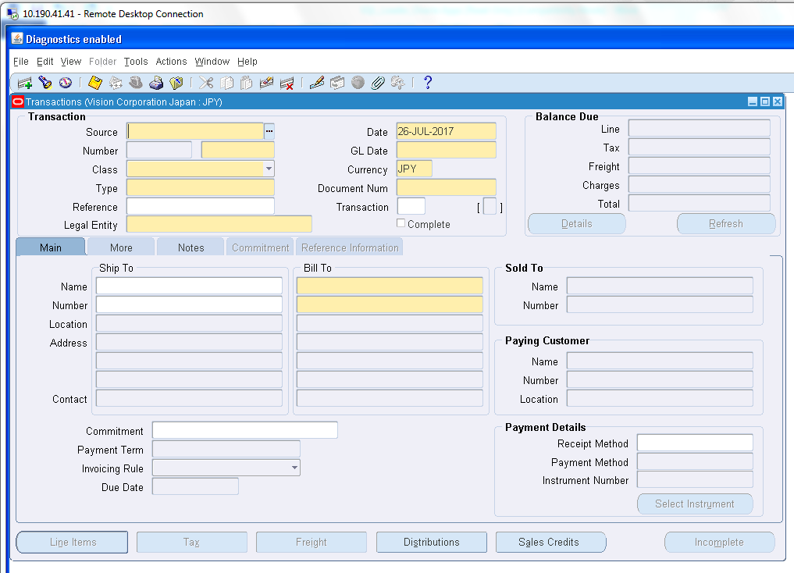

**2. Disabling the “Distributions” button**

* Go the Oracle Application and switch Responsibility to “receivable Super Vision Corporation Japan”.
* Navigate to Transaction - > Transaction.
* Here we see the Distribution Button, which we have to disable.

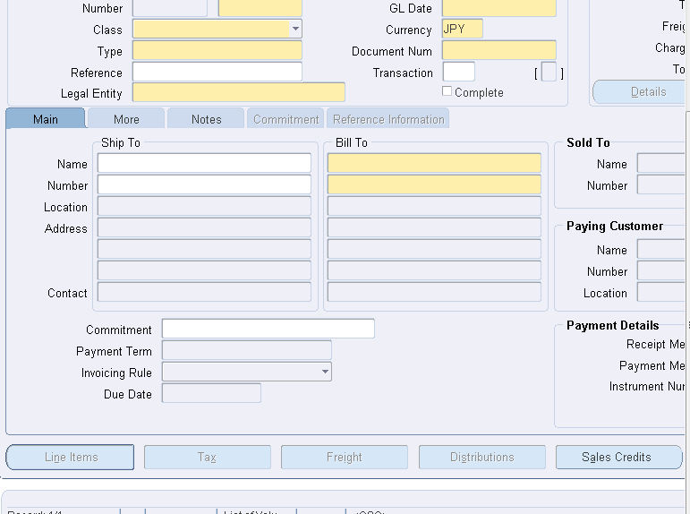

* Go to Help and personalize the rules form.
* Add a new rule “Disable Distribution button”.
* In the condition Block, assign the user to the “Level” and add the user whom can see the personalization.
* 
* After assigning User,Go to Actions Block.
* Assign Target Object as “TRW_HEADER.HEADER_ACCOUNTING” and
* Select Property Name = Displayed
* And Value = “FALSE”.
* 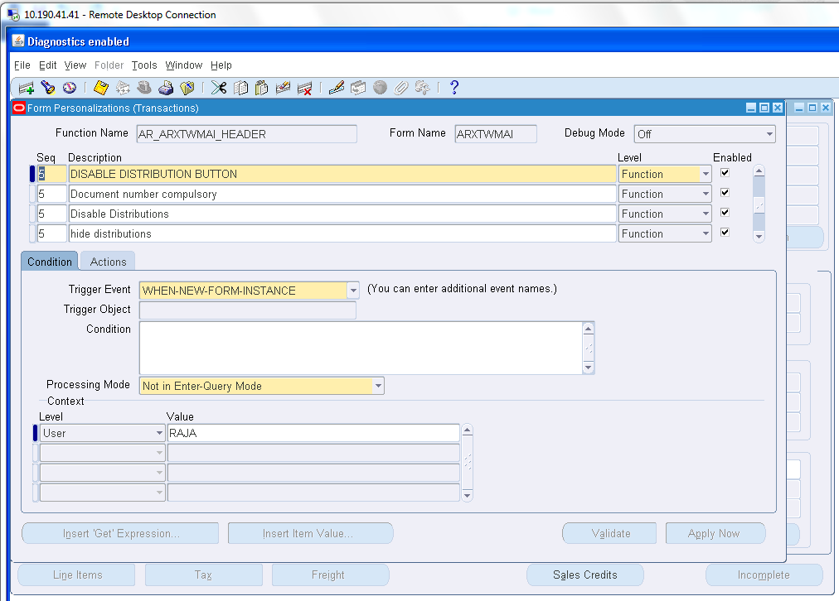

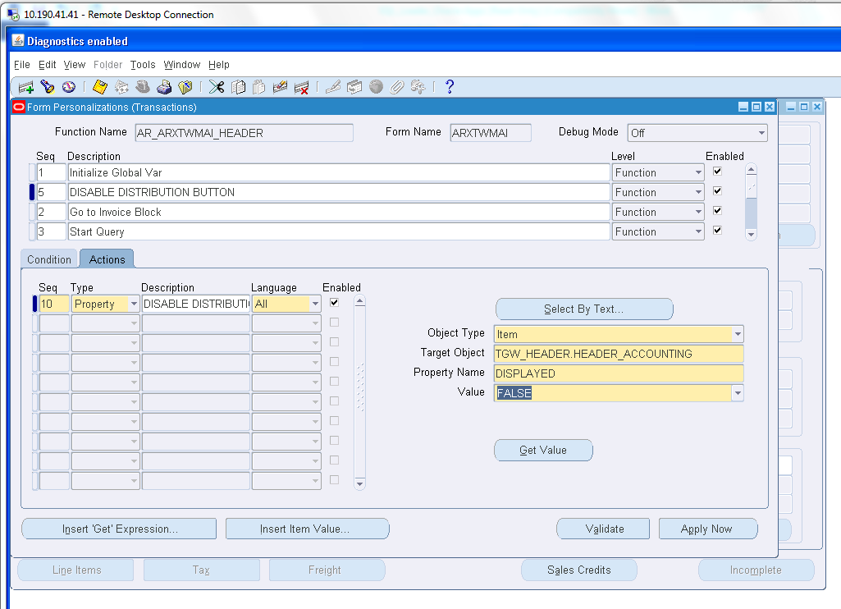

* AFTER ASSIGNING ALL THESE THINGS,VALIDATE THE RULE AND APPLY IT.
* NOW YOU CAN SEE IN THE TRANSACTION WINDOW,THE DISTRIBUTION BUTTON IS DISABLED AS SHOWN BELOW.

